Issue No. 1:
Remove this extra line from one of the mechanical layers.
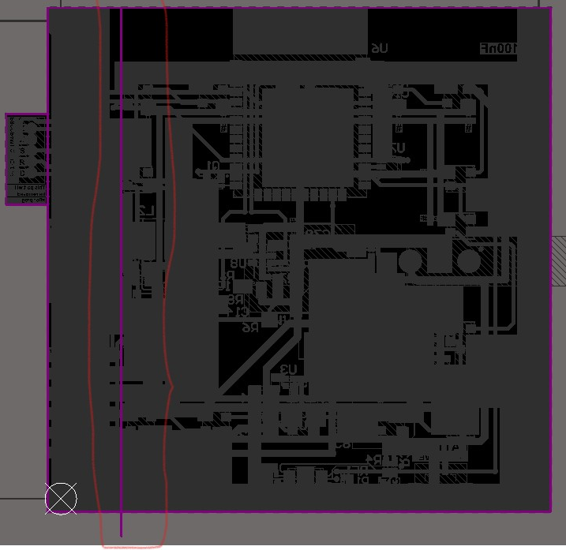

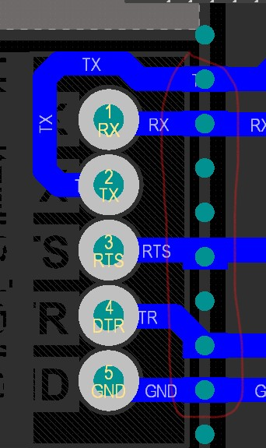
Issue No. 2:
Increase copper area under plated holes of mice-bites as minimum copper are may cause problem for us when we break breakable are of PCB.

Issue No. 3:
No Board cutout is present for ESP32 Module beneath its antenna area.
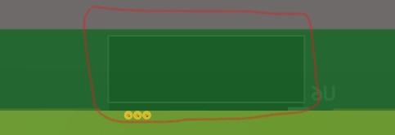

@Sidra also make sure followings points are also satisfied in our PCB.
- Dimension of PCB is according to client’s requirement.
- Placement of components is also according to client’s requirement.
- I have not found kind of logo (RoHS and Client’s suggested logo, if applicable). Ask Client for this.

